Azure for Students — Step‑by‑Step Signup Guide
This guide walks you through creating a Microsoft account, verifying your student status, activating the $100 Azure credits, and confirming the subscription.
https://learn.microsoft.com/en-us/azure/education-hub/about-azure-for-students

1) Before You Start (Checklist)
- Prepare the following: - Active college/university email ID (e.g., .edu, .ac.in, .edu.in)
- Mobile phone number (for OTP verification)
- Student ID card (only needed if manual verification is requested) - Stable internet connection
Personal email (Gmail, Yahoo, etc.) cannot be used for the student offer.

2) Create a Microsoft Account (Using Your Student Email)
- Go to: https://signup.live.com
- Click Use your email instead
- Enter your college email address
- Create a strong password
- Verify the OTP sent to your email
You now have a Microsoft account linked to your student email.
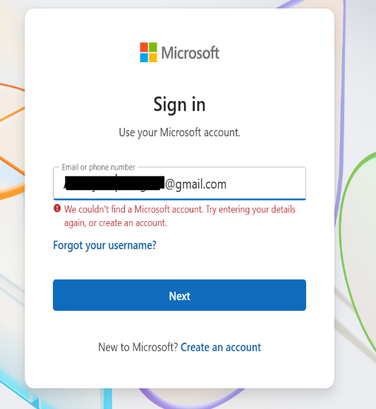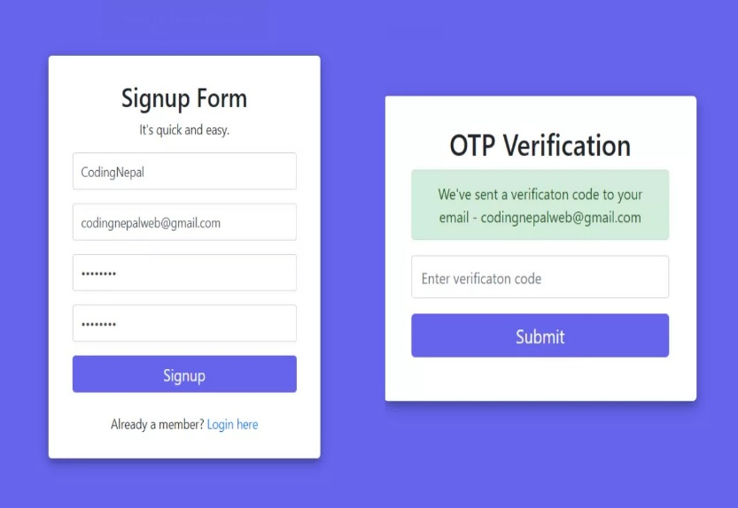
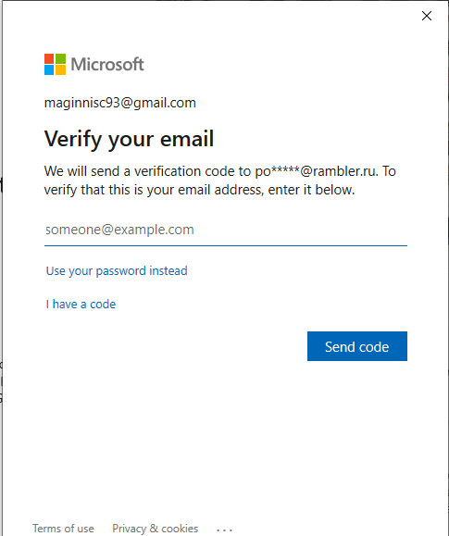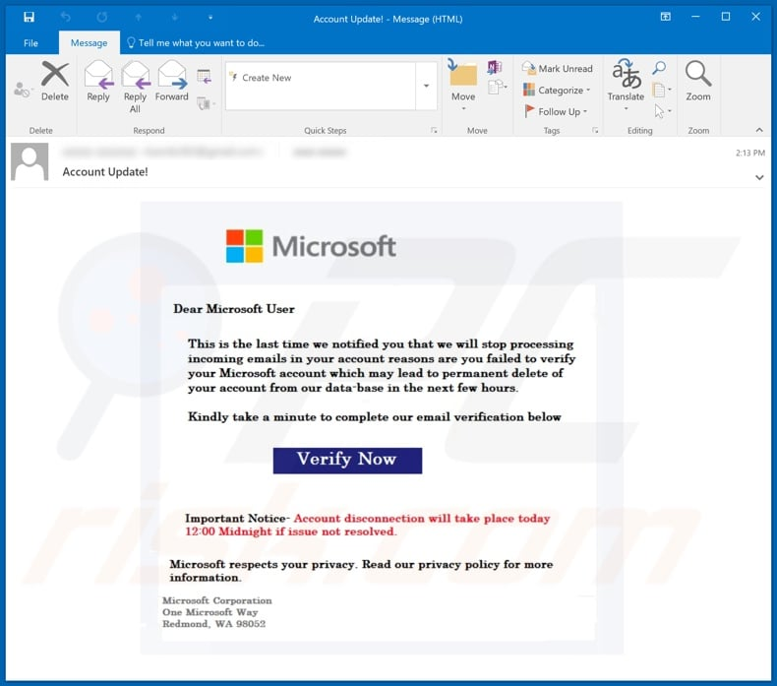

3) Open the Azure for Students Page
- Visit: https://azure.microsoft.com/en-in/free/students/
- Click Start free
- Sign in with the Microsoft account you just created
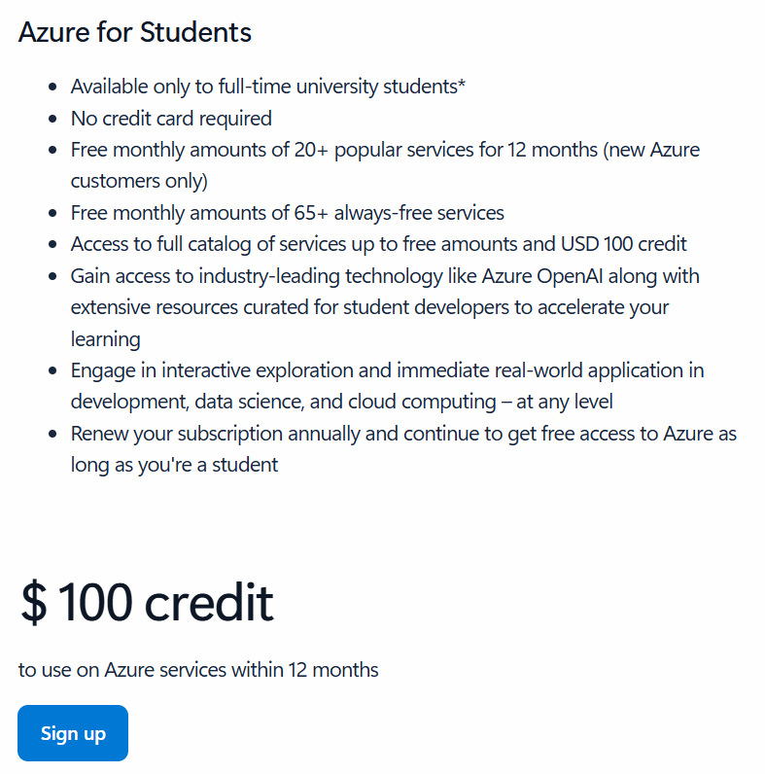

4) Verify Student Status
Azure will ask you to confirm that you are a student.

Automatic verification (most colleges)
- Re‑enter your student email
- Receive verification code
- Enter OTP
You will be instantly verified if your college domain is recognized.
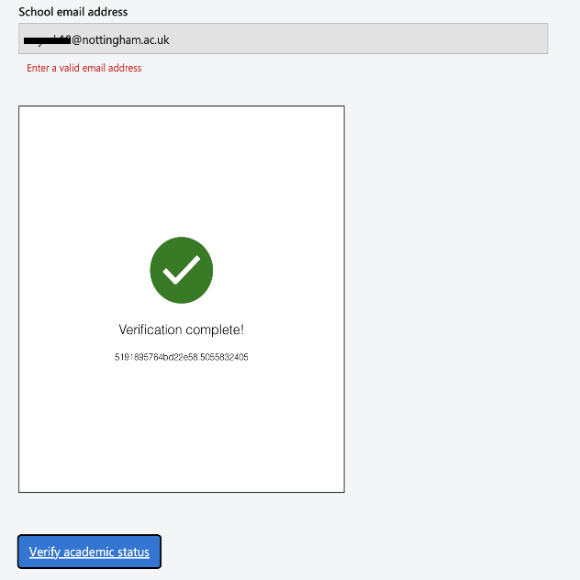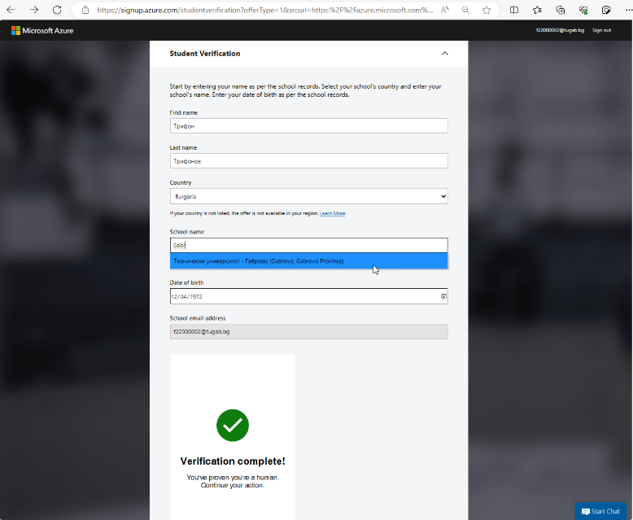
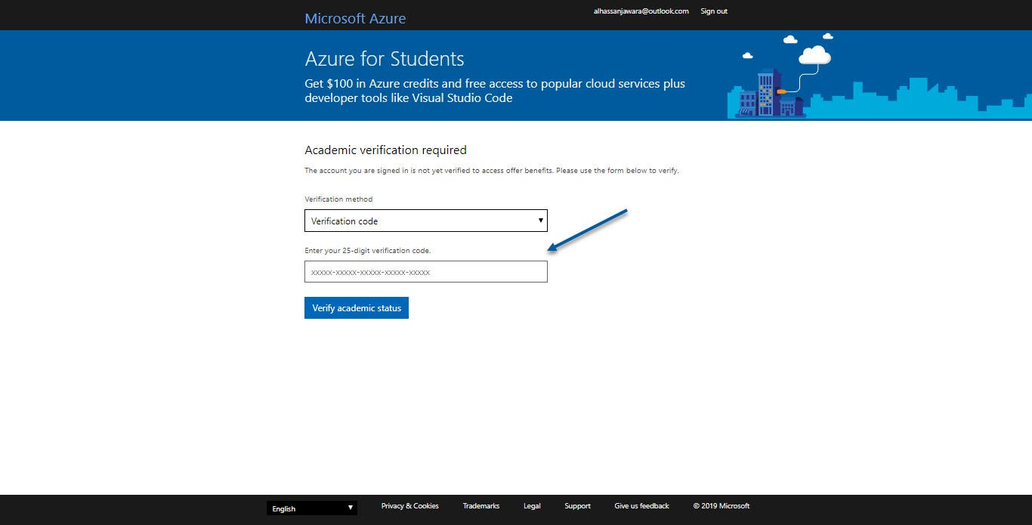
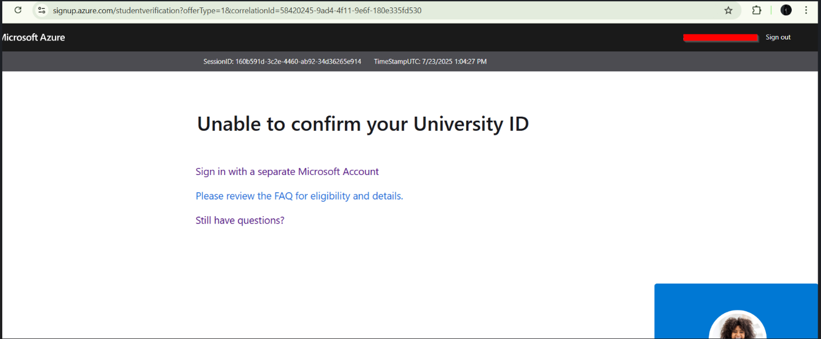

Manual verification (if required)
Upload one of the following: - Student ID card - Bonafide certificate - Fee receipt
Approval time: typically, 5–30 minutes (sometimes a few hours).

5) Phone Number Verification
- Enter your mobile number
- Receive SMS OTP
- Enter OTP to confirm
No credit card is required for Azure for Students.
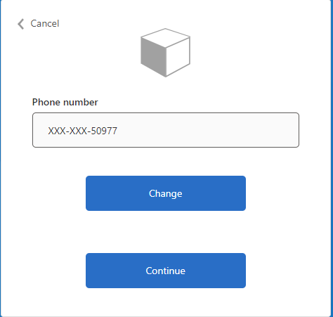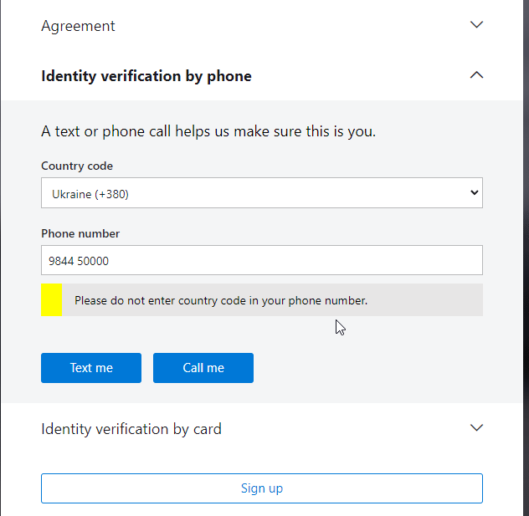
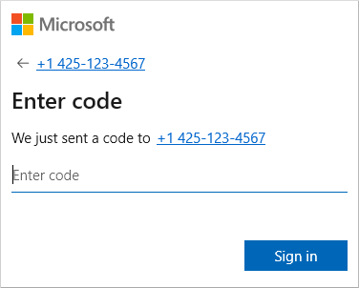

6) Activate the Subscription
- Accept the subscription agreement
- Click Activate
- Wait 1–3 minutes for setup
After activation, the Azure portal will open automatically.
You now receive: - $100 Azure credits (valid 12 months) - Access to always‑free services
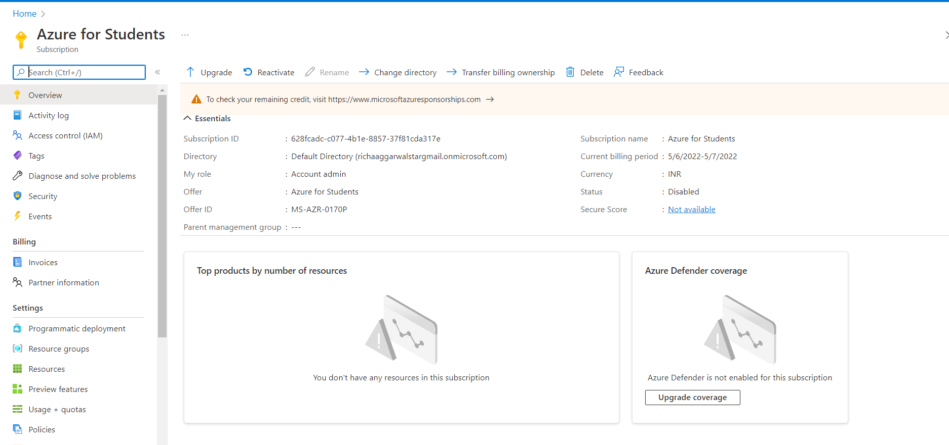
Right after activation, create a budget alert — many students accidentally run a large virtual machine, and the $100 disappears in 2 days.

7) Confirm Your Credits
- Go to: https://portal.azure.com
- Search Subscriptions
- Open Azure for Students
To check credit balance: 1. Search Cost Management + Billing 2. Click Credits 3. View remaining balance

8) Recommended Safety Step (Prevent Credit Loss)
Create a budget alert: 1. Cost Management → Budgets → Add 2. Amount: $90 3. Alert threshold: 80%
This prevents accidental usage of all credits.

9) Common Problems & Fixes

Not eligible
Possible causes: - Non‑student email - Expired college email - Already used Azure free trial before
Fix: Create a new Microsoft account using your student email and retry.

No verification email received
- Check spam folder
- Wait 10 minutes and resend

Credits show $0
You may be viewing the wrong subscription. Go to: Portal → Subscriptions → Azure for Students → Cost Management.
Tip: Start with small resources (B1s VM or free App Service) to avoid fast credit consumption.

